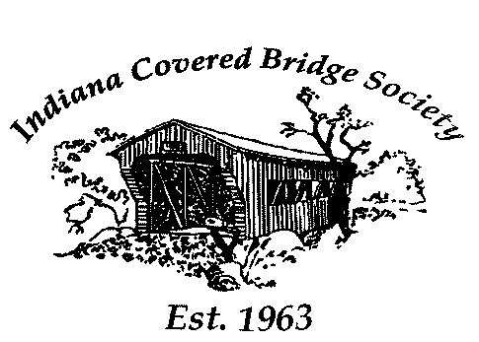
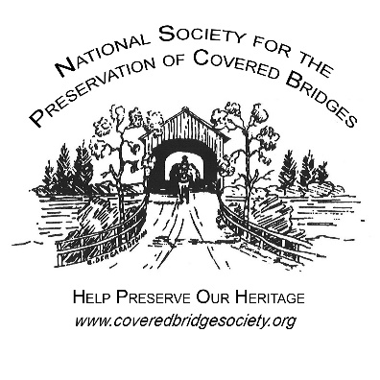
National Society for the
Preservation of Covered Bridges
& Indiana Covered Bridge Society
Western Indiana Tour
September 18 – 20, 2021
Base of operations:
Pear Tree Inn, 3050 S US Hwy 41 S, Terre Haute, IN 47802 Phone: (812) 234-4268. No group rate is available.
Call or reserve online at https://www.druryhotels.com/locations/terre-haute-in/pear-tree-inn-terre-haute.
Feel free to stay at the hotel of your choice. Many others are nearby. Gather at the Pear Tree Inn each morning.
The Bridges
Bridges planned to be included in the tour (with World Guide numbers and construction dates):
Friday evening, September 17:  Irishman 14-84-01 1845 or 1867  Saturday Morning, September 18:  West Union 14-61-27 1876  Bowsher Ford 14-61-33 1915  Eugene 14-83-05 1873 or 1885  Cades Mill 14-23-02 1854  Jackson 14-61-28 1861  Cox Ford 14-61-34 1913  Saturday Afternoon:  Narrows 14-61-36 1882 or 1883  Portland Mills 14-61-21 1856  State Sanatorium 14-61-38 1912  Beeson 14-61-24 1906  Billie Creek 14-61-19 1895  Phillips 14-61-12 1909  Sim Smith 14-61-14 1883  Melcher 14-61-26 1896  Sunday Morning, September 19:  Cataract Falls 14-60-01#2 1876  Dick Huffman 14-67-13 1880  Houck 14-67-11 1880 | Sunday Morning (continued):  Oakalla 14-67-10 1898  Dunbar 14-67-07 1880  Sunday Afternoon:  Pine Bluff 14-67-03 ????  Rolling Stone 14-67-04 1915  Bakers Camp 14-67-02 1901  Edna Collings 14-67-06 1922  Mansfield 14-61-20 1867  Big Rocky Fork 14-61-01 1900  Conley's Ford 14-61-02 1907  Bridgeton 14-61-04#2 2006  Monday Morning, September 20:  Mecca 14-61-13 1873  Crooks 14-61-17 1855  McAllister 14-61-16 1914  Neet 14-61-18 1904  Nevins 14-61-05 1920  Monday Afternoon:  Roseville or Coxville 14-61-09#2 1910  Harry Evans 14-61-10 1908  Zacke Cox 14-61-11 1908  Thorpe Ford 14-61-07 1912
Meals
A welcome reception is planned for Friday evening at the Barn in Fowler Park, near the Irishman Bridge.
We will pick up subs for Saturday’s lunch. Hamburgers & hot dogs at the Hobson Family Farm in Rockville for dinner.
Sunday’s lunch is at the Putnam Inn in Greencastle and pizza at the Britton Winery in Rockville for dinner.
On Monday, we will stop at Benjamin’s in Rockville for lunch. Nothing is planned for the evening.
Group Transportation
We are planning to rent 12-passenger vans to carry those who prefer to enjoy the tour while letting someone else do the driving. One of those vans will be driven by a local guide on Saturday & Monday routes in Parke County. NSPCB has graciously offered to contribute towards some of the van expenses.
More Information
To be added to a list for email updates, contact Bill Caswell at wscaswell@yahoo.com
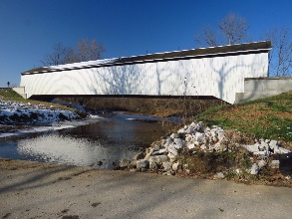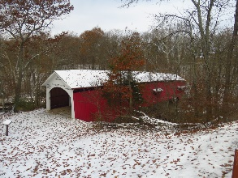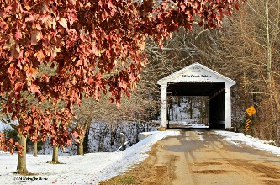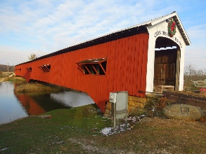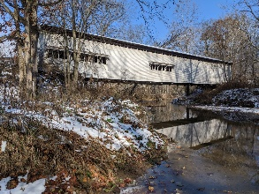
National Society for the
Preservation of Covered Bridges
& Indiana Covered Bridge Society
Western Indiana Tour
September 18 – 20, 2021
Registration Form

Base of operations:
Pear Tree Inn, 3050 S US Hwy 41 S, Terre Haute, IN 47802 (I-70, exit 7) Phone: (812) 234-4268.
No group rate is available.
Reservations at this hotel or one of the others in the area must be made by each individual.

To cover the costs of the group meals and State Park admission fees, we need to collect $70 from each attendee. That includes the Friday evening welcome reception at Vigo County Park, lunch & dinner on Saturday and Sunday’s dinner the Britton Winery. For lunch on Sunday & Monday, each person will order their own meal from the menu. This charge also includes admission to the two State Parks we will be visiting during the tour.
To properly plan the event, please let us know how many are in your group. Please complete this form and send it with a check or money order made payable to NSPCB to Andy Rebman, 546 Ramblin Rd, Greenwood, IN 46142 by Wednesday, September 1, 2021. We are looking forward to having you join us.

Name(s)

Address

City, State & Zip

Telephone Email:

Registration/Admissions/Meals ($70 per person) How many? _____ X $70 = _____________
Shuttle Transportation - To simplify parking and provide an opportunity for those who wish to enjoy the tour while leaving the driving to someone else, we have reserved passenger vans for the 3 days of the tour. NSPCB is helping offset the costs. The cost for tour attendees is $20 per person.
I/We would like to ride the bus. How many? _____ X $20 = _____________
Total Amount Enclosed (check or money order payable to NSPCB) _____________
To pay online, use Paypal to send payment to nspcb@yahoo.com.

